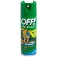****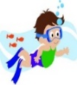****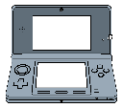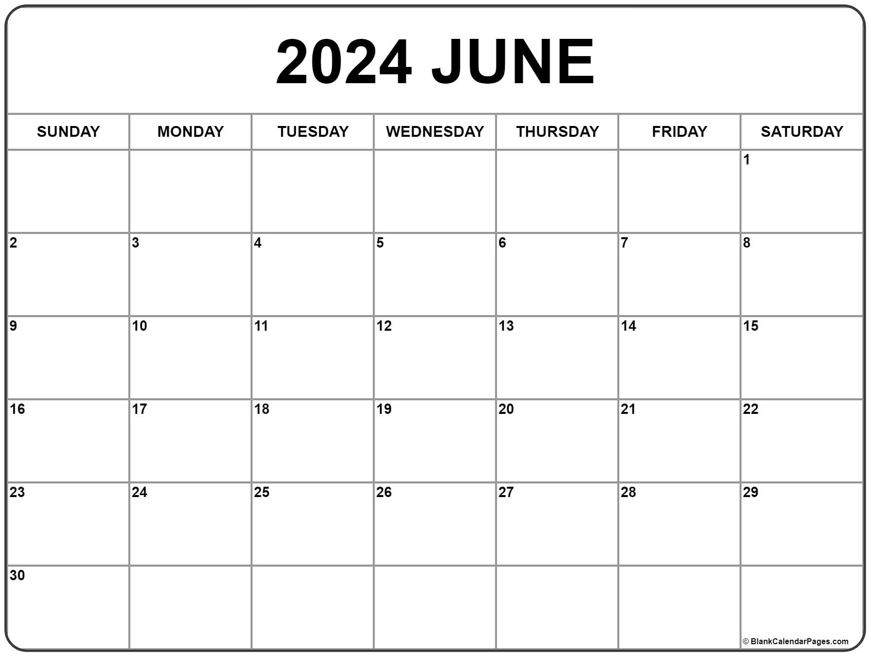

**Brickz for Kidz**

**on campus**

**12**

**Croc Encounters**

**Groups 2 & 3 only**

**PM field trip-Leave @**

**1 be back approx. 5 pm**

**13**

**Zephyr Park Splash Pad**

**Arrive @ TTPWS- 9 am**

**Be back approx. 2pm**

**5/29**

**Judy Moody & The Not Bummer Summer**

**5/31**

**Bonnie Brae Park**

**Arrive @ TTPWS- 9 am. Be back approx.. 12pm**

**25**

**Zathura: A Space Adventure**

**18**

**Hidden Figures**

**Biltmore Park**

**Arrive @ TTPWS-**

**9 am. Be back**

**approx. 12pm**

**FL Aquarium**

**On Campus**

**Under the Sea**

**Animal Planet**

**11**

**2019 Lion King**

**4**

**Luca**

**Giving Tree**

**Drum Circle on Campus**

**Friday**

**Thursday**

**Monday**

**Tuesday**

**Wednesday**

**1st Day of**

**Summer Camp**

**19**

**Lettuce Lake Park**

**Arrive @ TTPWS- 9 am**

**Be back approx. 2pm**

**5/28**

**Arrive @ TTPWS- 9 am**

**Be back approx. 2pm**

**Out of this World**

**5**

**Riverhills Park**

**Arrive @ TTPWS- 9am**

**Be back approx. 2pm**

**=Wear Red T-Shirt**

**Cultures Around the World**

**Summer Kickoff**

5/31

**5/30**

**Memorial Day**

**=Electronics Day! Kids can bring their gaming devices on MONDAYS ONLY, but if the item can receive internet access and take pictures or video, that feature must be disabled.**

**Themes**

**Calendar Key**

**=Movie on Campus**

**=Bring Bag Lunch (all items disposable)**

**=Wear Bug Spray**

**=Wear Sunscreen**

**=Bring Swimsuit**

**& Towel**

**May/June 2024 School Age Field Trip &**

**Activity Calendar**

****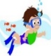************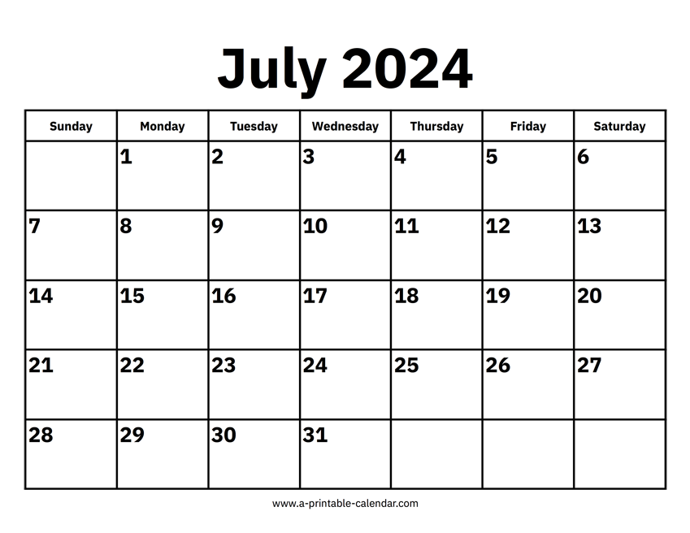

**Tampa Theatre Tour & SING Movie**

**Arrive @ TTPWS 8:30am**

**Be back approx. 12pm**

**Water Play Day on Campus**

**RIverside Park**

**Arrive @ TTPWS- 9am**

**Be back approx. 12pm**

**Whacky Tales**

**Alice In Wonderland**

**On Campus**

Lights, Camera, Action

Summer

Olympics



[This Photo](https://en.wikipedia.org/wiki/Olympic_Games) by Unknown Author is licensed under [CC BY-SA](https://creativecommons.org/licenses/by-sa/3.0/)

**1971 Willie Wonka & the Chocolate Factory**

**Herbie:**

**Fully Loaded**

**Gnomeo & Juliet**

**Jimmy Neutron**

**Boy Genius**

**Themes**

**=Bring Swimsuit**

**& Towel**

**5 All Groups to**

**Biltmore Park**

**Arrive @ TTPWS- 9 am. Be back approx. 12pm**

**Riverhills Park**

**Arrive @ TTPWS- 9am**

**Be back approx. 2pm**

**Lettuce Lake Park**

**Arrive @ TTPWS- 9 am**

**Be back approx. 2pm**

**Chef it up 2 Go**

**Cooking Activity**

**On Campus**

**Ben Lomond Park Arrive @ TTPWS- 9 am**

**Be back approx. 12pm**

**Blast from**

**the Past**

**Ooey Gooey**

**Science**

Party in

**the**

**Independence Day**

**July 2024 School Age Field Trip**

**& Activity Calendar**

**=Electronics Day! Kids can bring their gaming devices on MONDAYS ONLY, but if the item can receive internet access and take pictures or video, that feature must be disabled.**

**=Movie on Campus**

**=Bring Bag Lunch (all items disposable)**

**=Wear Bug Spray**

**=Wear Sunscreen**

**=Wear Red T-Shirt**

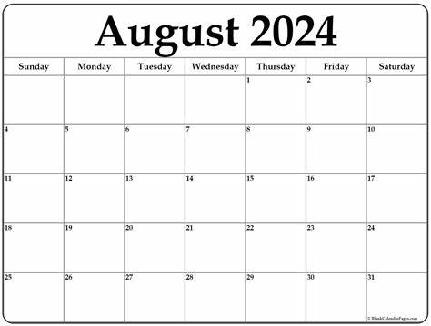

**SS American Victory Tour arrive @ TTPWS 9 am Be back approx. 2pm**

**TTPWS CLOSED for Cleaning & Training**

**Last Day of Summer Camp**

**For Childcare**

**Open for Meet & Greet 3 PM**

**August 2024 School Age Field Trip**

**& Activity Calendar**